Fahad Ali Khan

python practice lab work  - 153177

Fahad ali khan - 153177

**PYTHON PROBLEM:**

**Create a program that asks the user to enter their name and their age. Print out a message addressed to them that tells them the year that they will turn 100 years old.**

**Solution =**

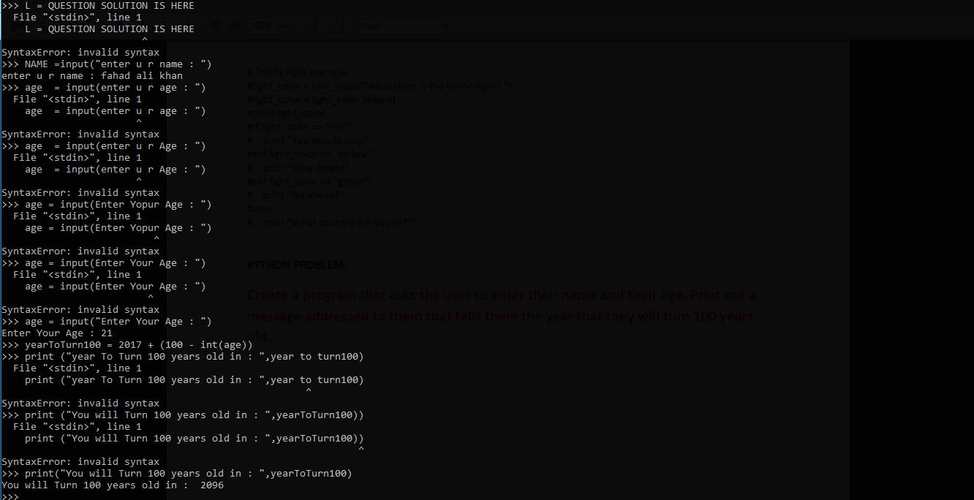

**Practice Problems =**



